Not Enough Anime Prepared me for This
  - Studying abroad in Japan as a Feminist Studies Student

This past summer I got the privilege to study abroad in Japan at Osaka University. It was a dream come true for me as I always wanted to visit the country since I was a young kid who got into anime and manga and found out I was part Japanese. It was a great opportunity to learn about the culture and history of a country that I have seen portrayed in the animes I consumed for years. Which is embarrassing for me to admit, but I’m not alone in that reason to go and visit Japan. Everyone else in my program also decided to study in Japan because of their anime interests.

I was hit with reality once I started living in Japan. The romanticization and hype that I’ve built up for years became grounded by the realities of learning to live in a culture that is the opposite of my own. In Japan, it is a collective society. There is the Japanese proverb that presents this best:
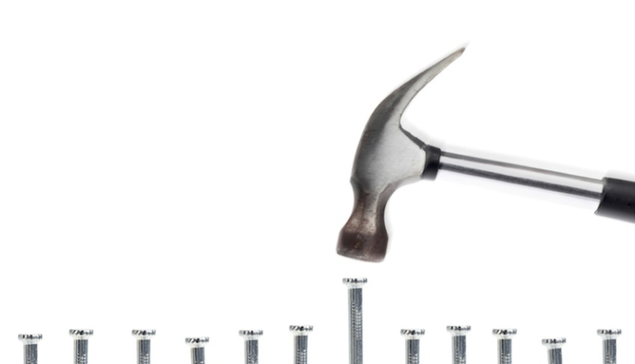
The Nail that sticks up, gets hammered down.
In other words, best to conform to majority rules to keep the harmony within the community and don’t do anything to rock the boat. Of course, this isn’t absolute and this does not apply to all Japanese people because they’re not a monolith. There are feminists and activists for LGTBQ minorities in Japan who disrupt the patriarchal system by calling attention to sexism, homophobia, and etc. But there is still this mentality to conform. It comes from a history where Japanese people had to rely on strangers in their villages to share the same food resource to ensure they survive. People had to be harmonious and try not to cause conflicts with others. Compared to the American culture of individualism where we are encouraged to have our own way of thinking and we are okay with having conflicts with strangers. We were able to do this because we have tons of land to space away from each other. So you can try to understand that having to conform to another set of rules you’re not used to living with.

One of them was a sexist dress code in Japan. I researched about the culture about Japan before when I was young and never ran into the topic. By the time I got my acceptance into the study abroad program, which was six months before my departure, I started researching about Japanese culture again to prepare myself. I knew about the hot weather, the conforming mentality, having to deal with cockroaches and such. I also followed English translated current Japanese news that the EAP suggested to us. And I was still not prepared for what the staff presented at orientation.

At orientation, the university and EAP staff went over the information we would need to know about living in the neighborhood, going over a map of where the groceries and pharmacies are, information about the university, and how to deal with mosquitos in the hot humid summer of Japan. One part of the orientation talked about Title IX, if you don’t know what Title IX is, it is the right that students cannot be discriminated on the basis of sex to be excluded from or denied any education program or activity. It’s been historically used to include women in college sports and to file sexual harassment lawsuits. The Osaka University staff talked about Title IX to deal with sexual harassment. The speaker, who was male, said “Remember guys, don’t sexually harass the women. If a woman says no, it means no. And remember women, don’t sexually harass the men.” To which I thought was fair enough, because there are men who are victims of sexual harassment too, but the next part wasn’t fair. The speaker goes to the next slide which shows a picture of four white UCSB sorority girls wearing tank tops and shorts doing with their faces blurred out.

This is the closest example I can give of the photo the university showed us.

What made it worse was one of the other study abroad staff said that they didn’t get a chance to ask the sorority girls’ permission to use the picture, but thought it was okay to use the pictures since the faces were blurred out, and I felt livid. I was angry and confused because there was nothing I read about this in my internet research, I haven’t seen any articles from the English Japanese News sites, and I definitely never seen this point brought up in any animes I watched so I was caught off guard.

The closest we warned was our EAP counselor telling us to bring cardigans while we’re in Japan because the establishments get cold inside with the air conditioning. But when I was walking around in 98 degrees Fahrenheit with lots of humidity and I finally reached a place with air conditioning, I definitely didn’t need a cardigan. None of the previous meetings with the university staff or other students who went abroad to Japan or to our same program ever told us or made any mention of this dress code. I and other female students in the program were mad since it slut shamed women, but there was not much we could do since we all packed a summer wardrobe for the program. We weren’t very vocal about this unless we complained about it to each other, we were foreigners in a different country. It was hard to navigate that fine line, we didn’t want to be offensive to the Japanese people who hosted us in their country, but we weren’t exactly happy about the conditions either.

So showing shoulders was a way of women sexually harassing men, in Japan. It was evident during my stay that showing shoulders was a big “no” in the Kansai region of Japan. Wherever my friends and I shopped, we found tops that covered the shoulder (even if it was sleeveless tops), and there were no shirts that scoop neck, v neck, or cold shoulder cuts. The shorts and skirts that were sold were long.

This was something new I learned about Japanese culture, that showing to much skin can be seen as to sexy, to the point it can be considered sexual harassment. When I talked to some of the Japanese study abroad staff they talked about the cold shoulder cut top I wore as “too sexy.” I talked to one of my Japanese friends about the too sexy shoulders thing and it is a thing there. Japanese people would assume those who do show their shoulders are tourists and foreigners. I felt like I had a pass because I was a foreigner and wasn’t prepared for that situation. So I and the rest of female students in my program just wore our American summer wardrobe during our stay in Japan.

This counts as “too sexy” in Japan and apparently sexual harassment.

But I noticed something when I wore my summer clothing that had a scoop, v neck, or cold shoulder cut on my tops I bought from US stores like American Eagle and Forever 21. I would get a lot of judging stares from all Japanese people, men, and women, young and old. It got uncomfortable. I ended up getting ogled by old men, and there was nothing I could do much about it. There was even a point where an old man on the bus tried to get me off at his stop because of the top I was wearing. In our study abroad Japan guides that EAP had for us instructed that if we were sexually harassed by men on trains was not do anything to bring attention to ourselves and quietly say “やめてください.” (yamete kudasai) which translates to “Please stop it.” Since I didn’t want to bring attention to myself from the old Japanese men that ogled that was away from me I would glare at them until they stopped looking at me.

I thought I had a pass because I was a foreigner and dressed like one, until it hit me. I also ended up passing as Japanese. I am part Japanese, but I am also Filipino and Chinese, but I guess I was ambiguous enough to pass as Japanese. Most of my other female friends didn’t run into this problem because they looked like obvious foreigners, they were white, black, or looked more obviously South Asian or Southeast Asian due to their skin color. Dealing with this for two months got tiring.

Overall my stay in Japan was great but also tiring and stifling. It was hard living as a foreigner in Japan, I noticed a lot of the sexism in Japan but I had to deal with it differently there than I would in America. I realized the truth that I would never be able to live permanently in Japan because of its’ sexist conservative society and that I will always be considered a foreigner in Japan.

Being a feminist studies student, my work relies on being a disruptor to call attention to the ways that marginalized people tend to be oppressed in the patriarchal system we’re born into. But it would be harder for me to navigate how to be a disruptor in Japan compared to America. Especially because I wouldn’t even be considered a true Japanese there. One of my Japanese teachers talked about how Japanese people won’t consider foreign people as Japanese even if I get Japanese citizenship. I would have to have pure Japanese blood and be born there. Plus, I would have to deal with the colorism and Asian ethnicity superiority complex in Japan, and I don’t want to deal with that. I’m not saying in any way that America is better than Japan in sexism, we’re not that well off, and most people are okay with a president that sexually harass women. We still have a lot of work to do, but I would know better how to navigate being a feminist in America than in Japan.

Living there for two months I learned I didn’t want to live in Japan. I did not want to deal with the sexism and slut shaming, along with the mental health stigma over there (but considering they have good healthcare and gun control, it’s really tempting to live there). Instead, I rather live there temporarily or come back as a tourist. You have a much different experience as a tourist in a foreign place. You’ll mainly go to touristy places, you’re only there for a short time, and you’ll obviously look like a foreigner. When you live as a foreigner in a foreign place, you have to adjust your mentality to fit a new one. And it can be hard. I always thought living in Japan would be like how it is in the animes I watched. In some ways they were in looks and appearances, but it was different being in that environment.

I don’t want this post to discourage anyone from deciding to visit, to live, or to study abroad in Japan. I just want give people a heads up on what to expect in Japan. If you want to go to Japan or do the study abroad program, I highly recommend it. Know that there will be some lows you’ll find when you travel abroad, but it shouldn’t define the place or the trip. I know for me I’ll definitely be coming back to Japan as a tourist and keep visiting all the places I can. It’s a very beautiful place, rich with history, culture, and good food that dates back to over hundreds of years ago. At least I’m more prepared for next time when I’ll visit.

